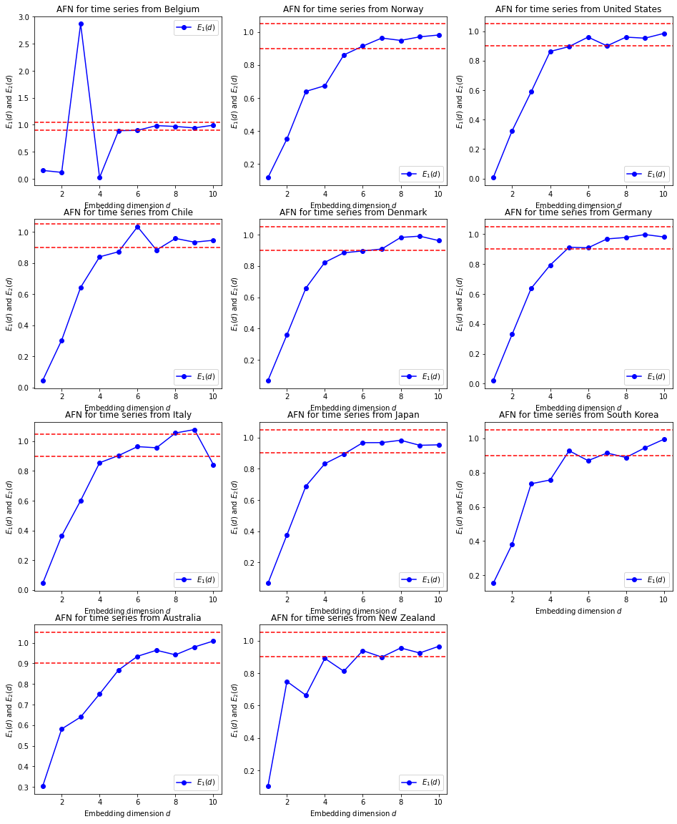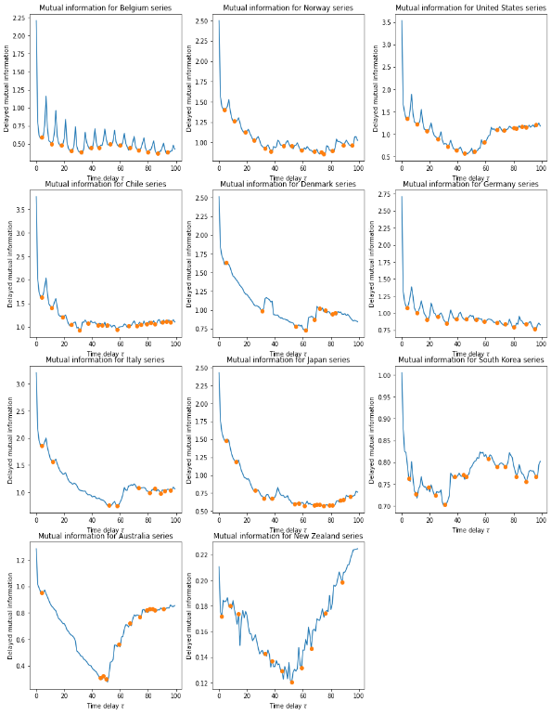

Figure Supplementary 1. Curves to compute the minimum embedding dimension and the time delay for the series of incidence of the 11 considered countries.

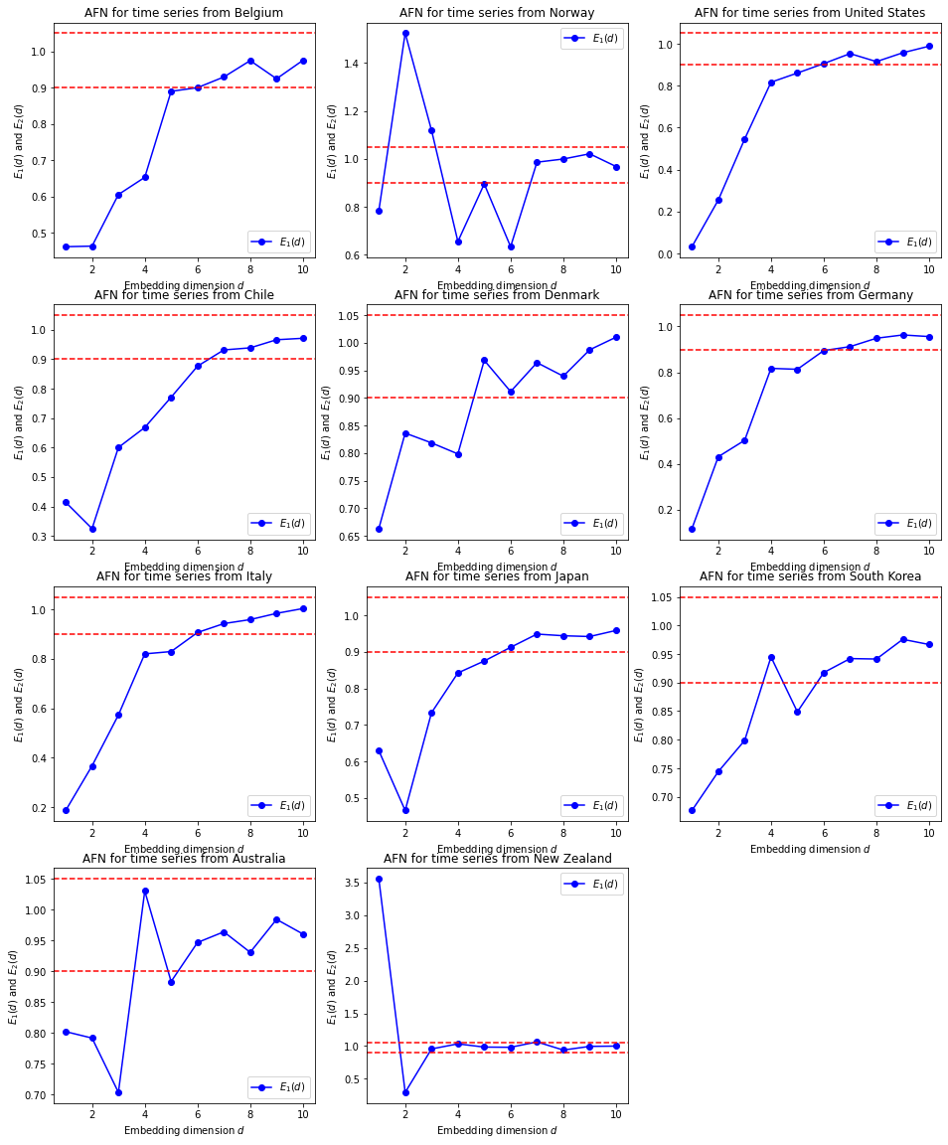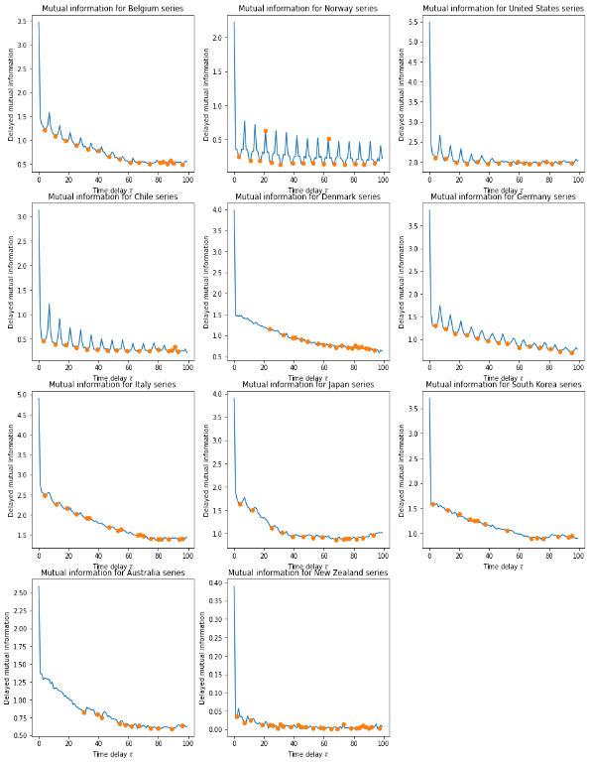
Figure Supplementary 2. Curves to compute the minimum embedding dimension and the time delay for the series of deaths per 100,000 inhabitants of the 11 considered countries.

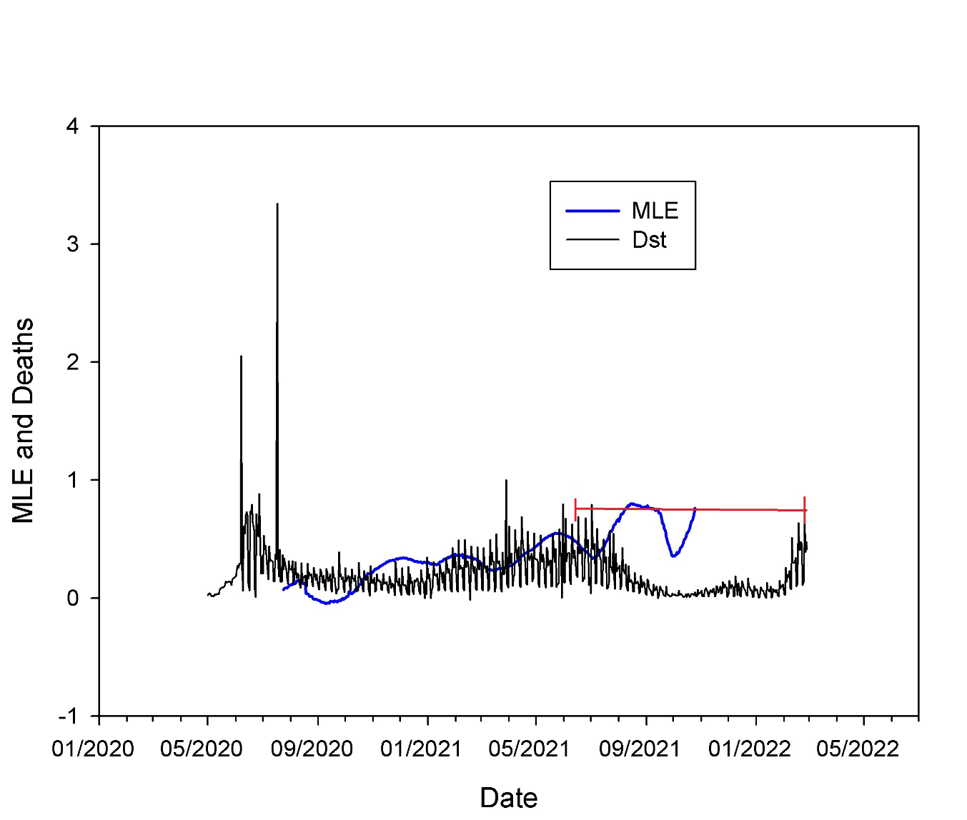

Figure supplementary 3. Maximum Lyapunov exponent (MLE: blue line) and standardized deaths (Dst: number of deaths/316; arbitrary value to make MLE and Deaths comparable in the figure) (black line) vs Date in Chile. The red line shows the time window to estimate MLE.

